**STUDENT HELPDESK MANAGEMENT SYSTEM**

**A MINOR PROJECT REPORT**

***Submitted by***

**MOHD ARHAM**

**2020-310-142**

***in partial fulfillment for the award of the degree of***

**B.TECH COMPUTER SCIENCE ENGINEERING**

***Under the supervision of***

**DR. IMRAN HUSSAIN**



**Department of Computer Science**

**JAMIA HAMDARD**

**(Hamdard University)**

**New Delhi-110062**

**(2023)**

DECLARATION

I, **Mr. Mohd Arham** a student of **Bachelors in Technology Computer Science Engineering(B.Tech C.S.E.) , Enrolment No : 2020-310-142** hereby declare that the minor project entitled **“STUDENT HELPDESK MANAGEMENT SYSTEM”** which is being submitted by me to the Department of Computer Science, Jamia Hamdard, New Delhi in partial fulfillment of the requirement for the award of the degree of  **Computer Science ,** is my original work and has not been submitted anywhere else for the award of any Degree, Diploma, Associateship, Fellowship or other similar title or recognition.

**MOHD ARHAM**

**Date: 02-05-2023**

**Place: JAMIA HAMDARD**

ACKNOWLEDGEMENT

I would want to express my gratitude to a number of persons who have encouraged and assisted me in the preparation of this project, both directly and indirectly. It allows me to look back and reflect on the support I've had during this process.

I would like to express my gratitude to **Dr. Imran Hussain**, my mentor, as well as the professors of Jamia Hamdard University, for their invaluable recommendations, innovative criticisms, and support throughout the writing process. I would like to offer my heartfelt gratitude to the entire faculty of Jamia Hamdard University (SEST).

My heartfelt gratitude goes out to my family and friends, as well as my esteemed university,

Jamia Hamdard, for providing me with the chance and infrastructure to complete this project. Finally, I want to express my gratitude to everyone who assisted me in gathering data during the creation of the project, without whom it would not have been possible.

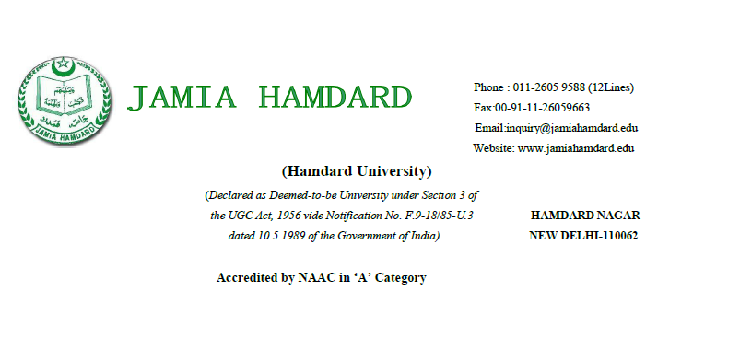

CERTIFICATE

On the basis of the declaration submitted by **Mohd Arham (Enrolment No: 2020-310-142)** a student of **B.Tech (Computer Science and Engineering)**, I hereby certify that the minor project entitled **”STUDENT HELPDESK MANAGEMENT SYSTEM”** being submitted to the Department of Computer Science & Engineering, Jamia Hamdard, New Delhi is partial fulfillment of the requirement for the award of the degree **of B.Tech (Computer Science and Engineering)** is carried out by him under my supervision.

**Dr. Farheen Siddiqui**

Head of department

Department of CSE

Jamia Hamdard

**Dr. Imran Hussain**

(Supervisor)

Department of CSE

Jamia Hamdard

**TABLE OF CONTENTS**

1. Abstract ………………………………………….….Page 1

2. Objective …………………………………………. ..Page 2

3. Introduction …… …………………..………………..Page 3

4. Problem Statement …………………………….... …Page 4

5. Use Case Diagram ……………………………..... ….Page 5

6. Cost/Effort Estimation ……….……………………...Page 6

7. Gantt Chart ………………………………………….Page 7

8. Entity Relationship Diagram ………………………..Page 8

9. Activity Diagram ……………………………………Page 9

10. Snapshots of different input and output screens …...Page 10

11. Benefits………………………………………………Page 16

12. Features ……………………………………………..Page 18

13. Conclusion …………………………………………Page 20

14. Limitation And Future Scope ……………………...Page 22

15. Bibliography ……………………………………….Page 23

**ABSTRACT**

* The Student Helpdesk project is an online platform that facilitates communication between students and the university administration. The system provides a centralized location for students to submit queries related to academics, administrative issues, or any other concerns they may have.
* The project aims to streamline the process of handling student queries and reduce the response time of the university administration. This report outlines the development process of the Student Helpdesk project, including the objective, problem statement, use case diagram, class diagram, entity relationship diagram, Gantt chart, and conclusion.

**OBJECTIVE**

* The Help Desk Management System is a set of programs which run as a software providing assistance to all the complaints, queries and services to the customers within a set of organization. It is a web based software which has made the working procedure of organization much easy.
* This software will fulfill customer’s need by providing them technical support for their relevant issues as well as time period considered for solving the problems will be much shorter. All the queries and issues that will be posted in portal will be saved into the database for future reference.
* The software is an intranet based software which can be used within the organization. It is basically a customer care management system. This software is very efficient in future time because it is an E-help desk system which tries to solve the problems of all the customer via internet medium and digital medium and thus reducing even the working time for the users too, to solve their problems and queries.

**INTRODUCTION**

* A web-based student helpdesk system is an online platform that enables students to request academic, technical, and administrative support from their educational institution.
* The system is accessible from anywhere with an internet connection, making it easier for students to receive timely assistance and improve their academic experience. Overall, a web-based student helpdesk system is a powerful tool that can enhance the academic experience for students and help institutions provide better support and services.

**PROBLEM STATEMENT**

* The current process of handling student queries at our university is inefficient and time-consuming. Students are required to visit different departments and fill out physical forms to submit their queries. The university administration also lacks a centralized system to manage and respond to student queries. As a result, students face delays in getting their queries resolved, and the university administration is burdened with the task of manually managing a large volume of queries.
* The objective of the Student Helpdesk project is to address these issues by providing a centralized platform for students to submit and manage their queries and for the university administration to respond to these queries in a timely manner.

**USE CASE DIAGRAM**

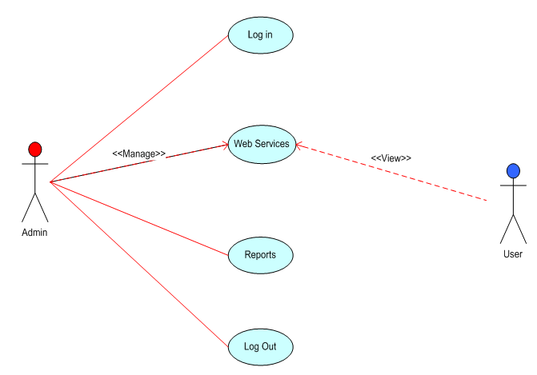

**EFFORT ESTIMATION BASED ON MODEL**

**GANTT CHART**

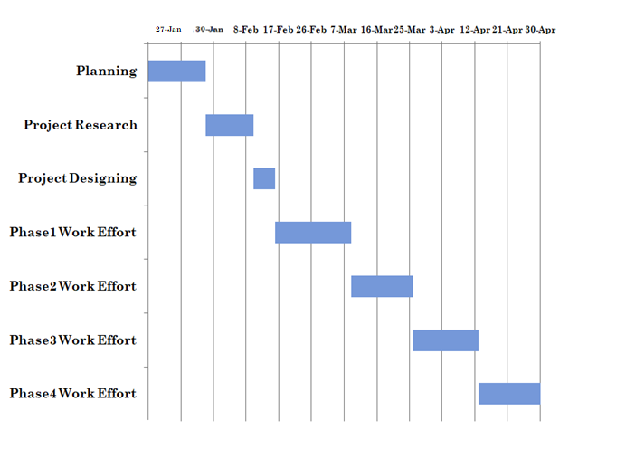

**ENTITY RELATIONSHIP DIAGRAM**

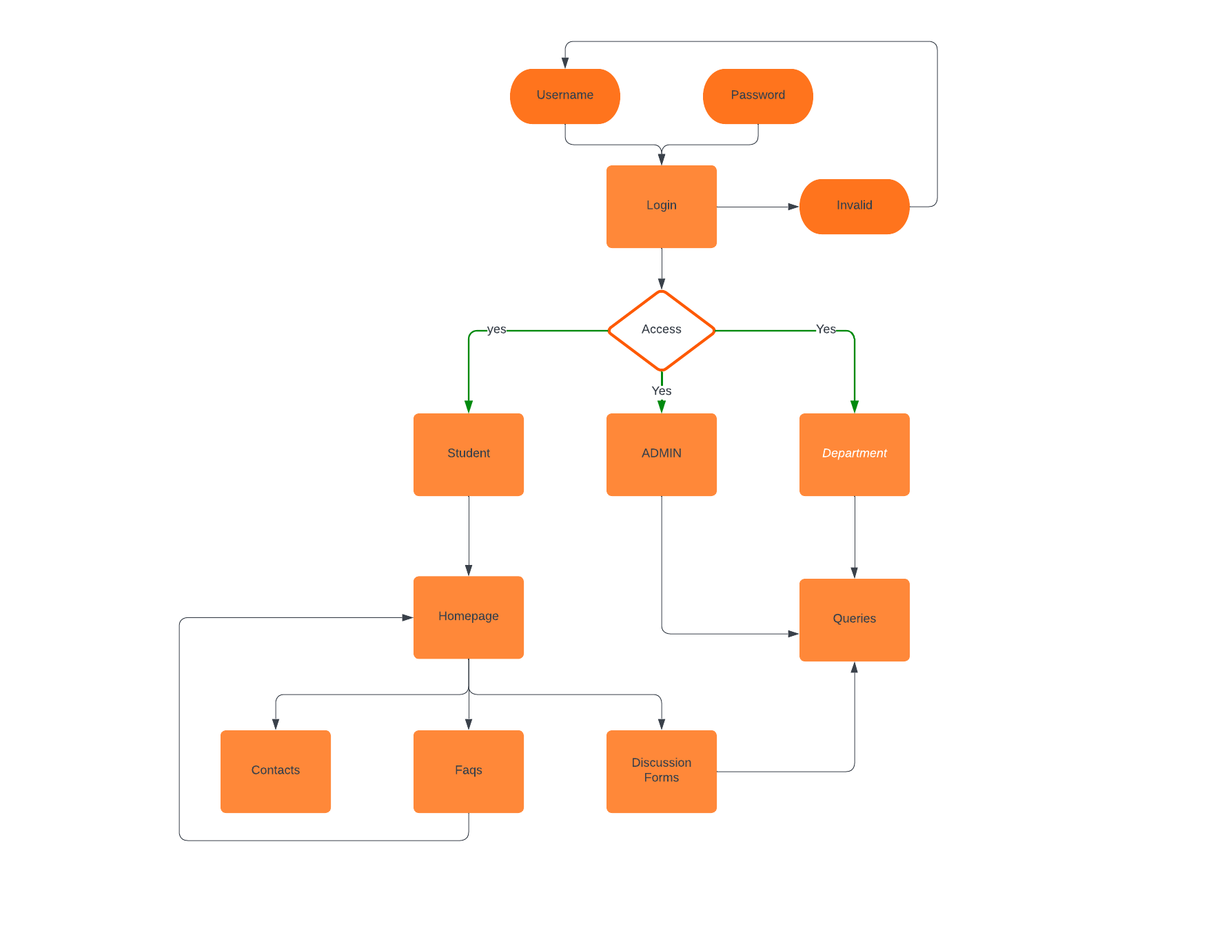

**ACTIVITY DIAGRAM**

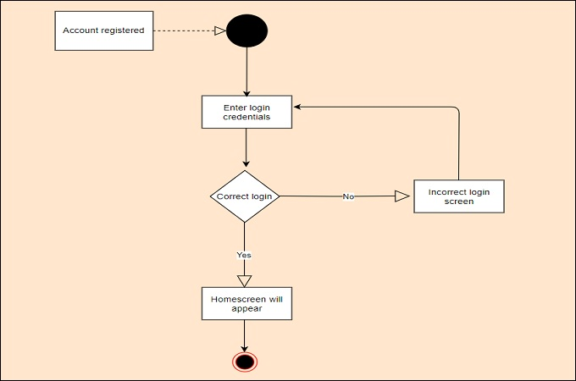

**SNAPSHOTS**

*HOMEPAGE*

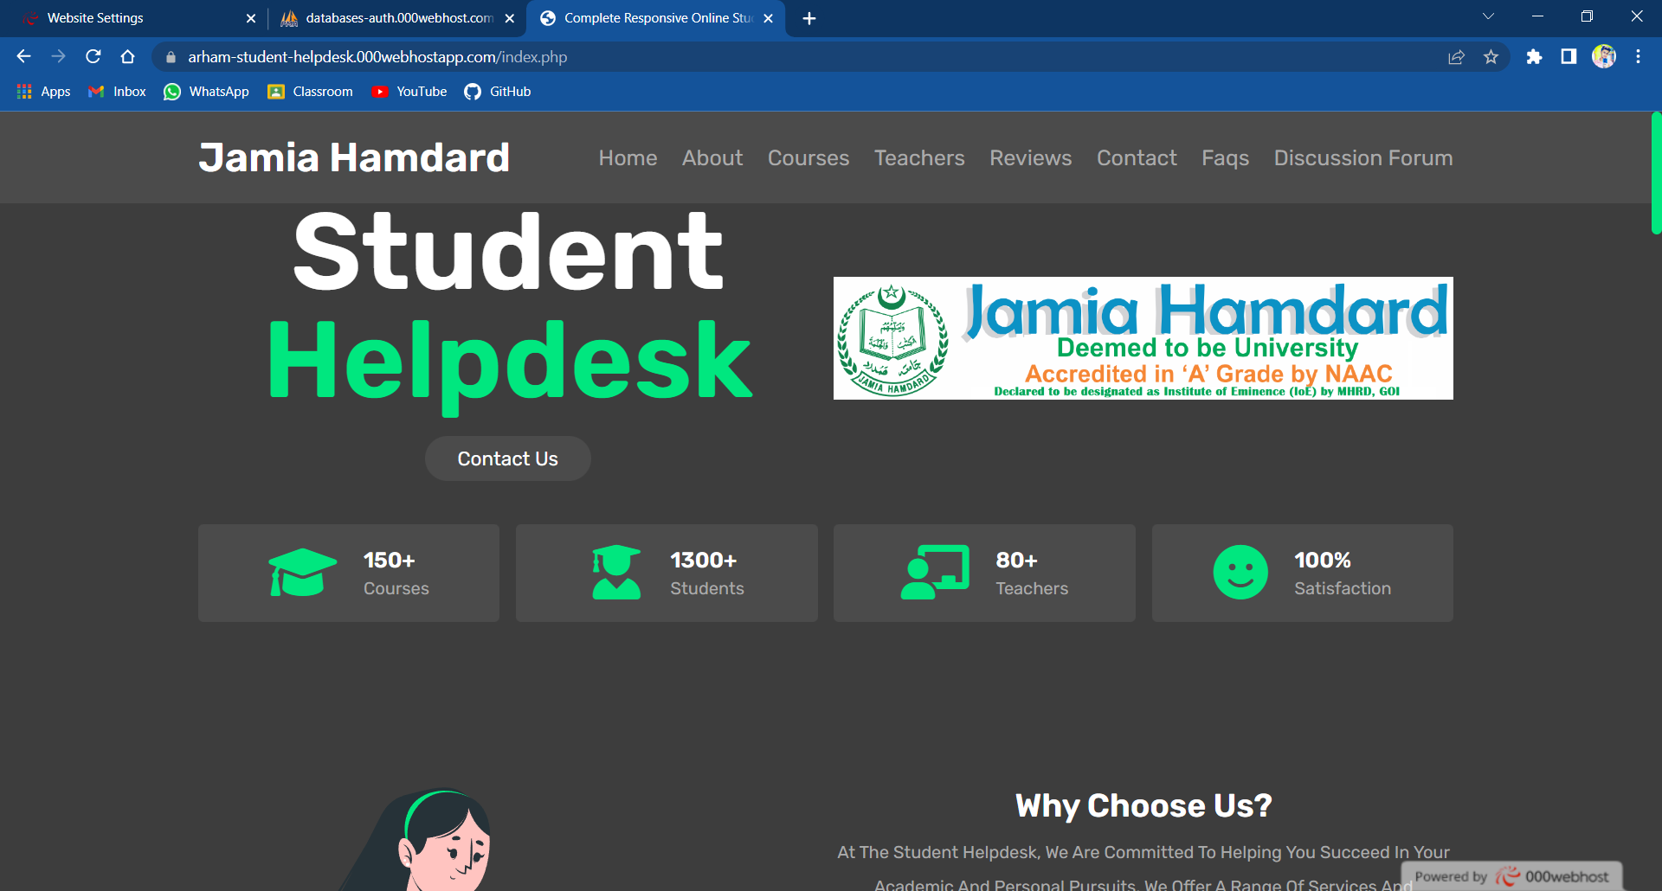

*ABOUT*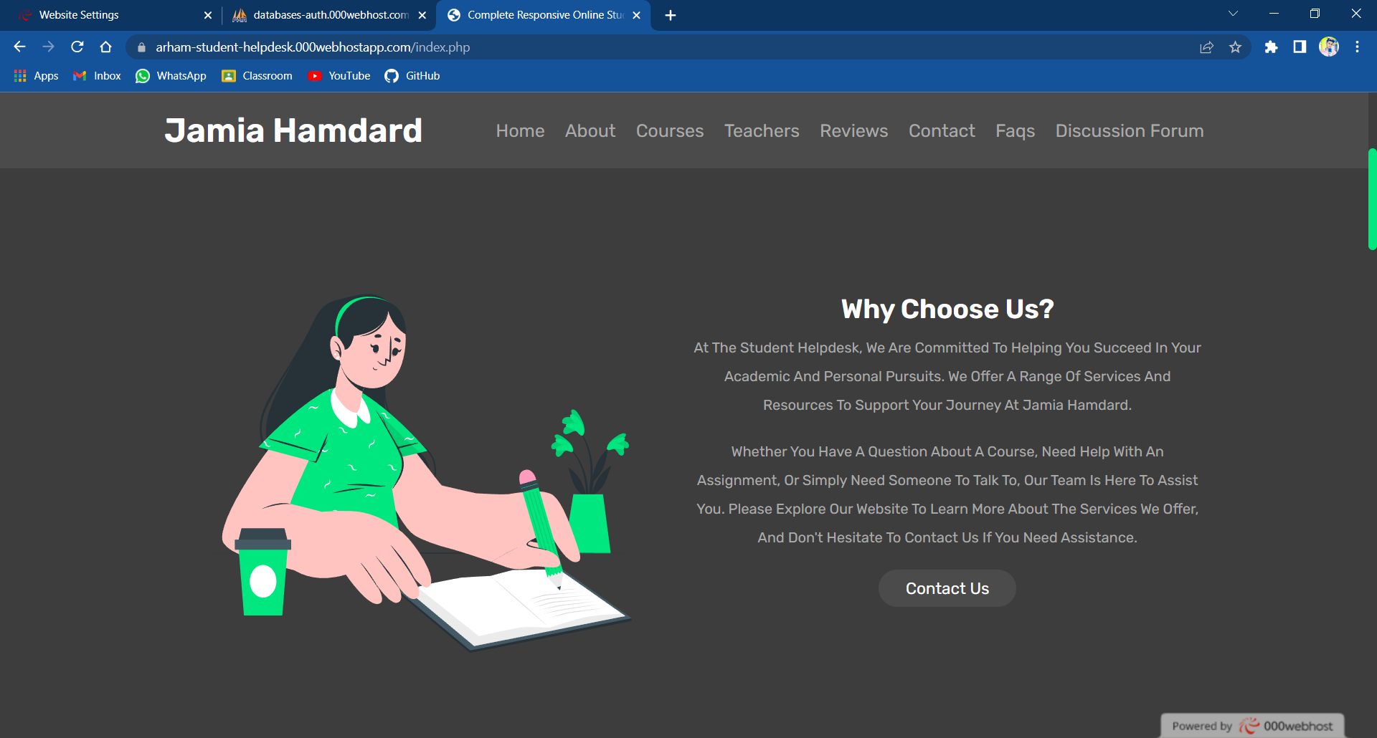

*TEACHERS*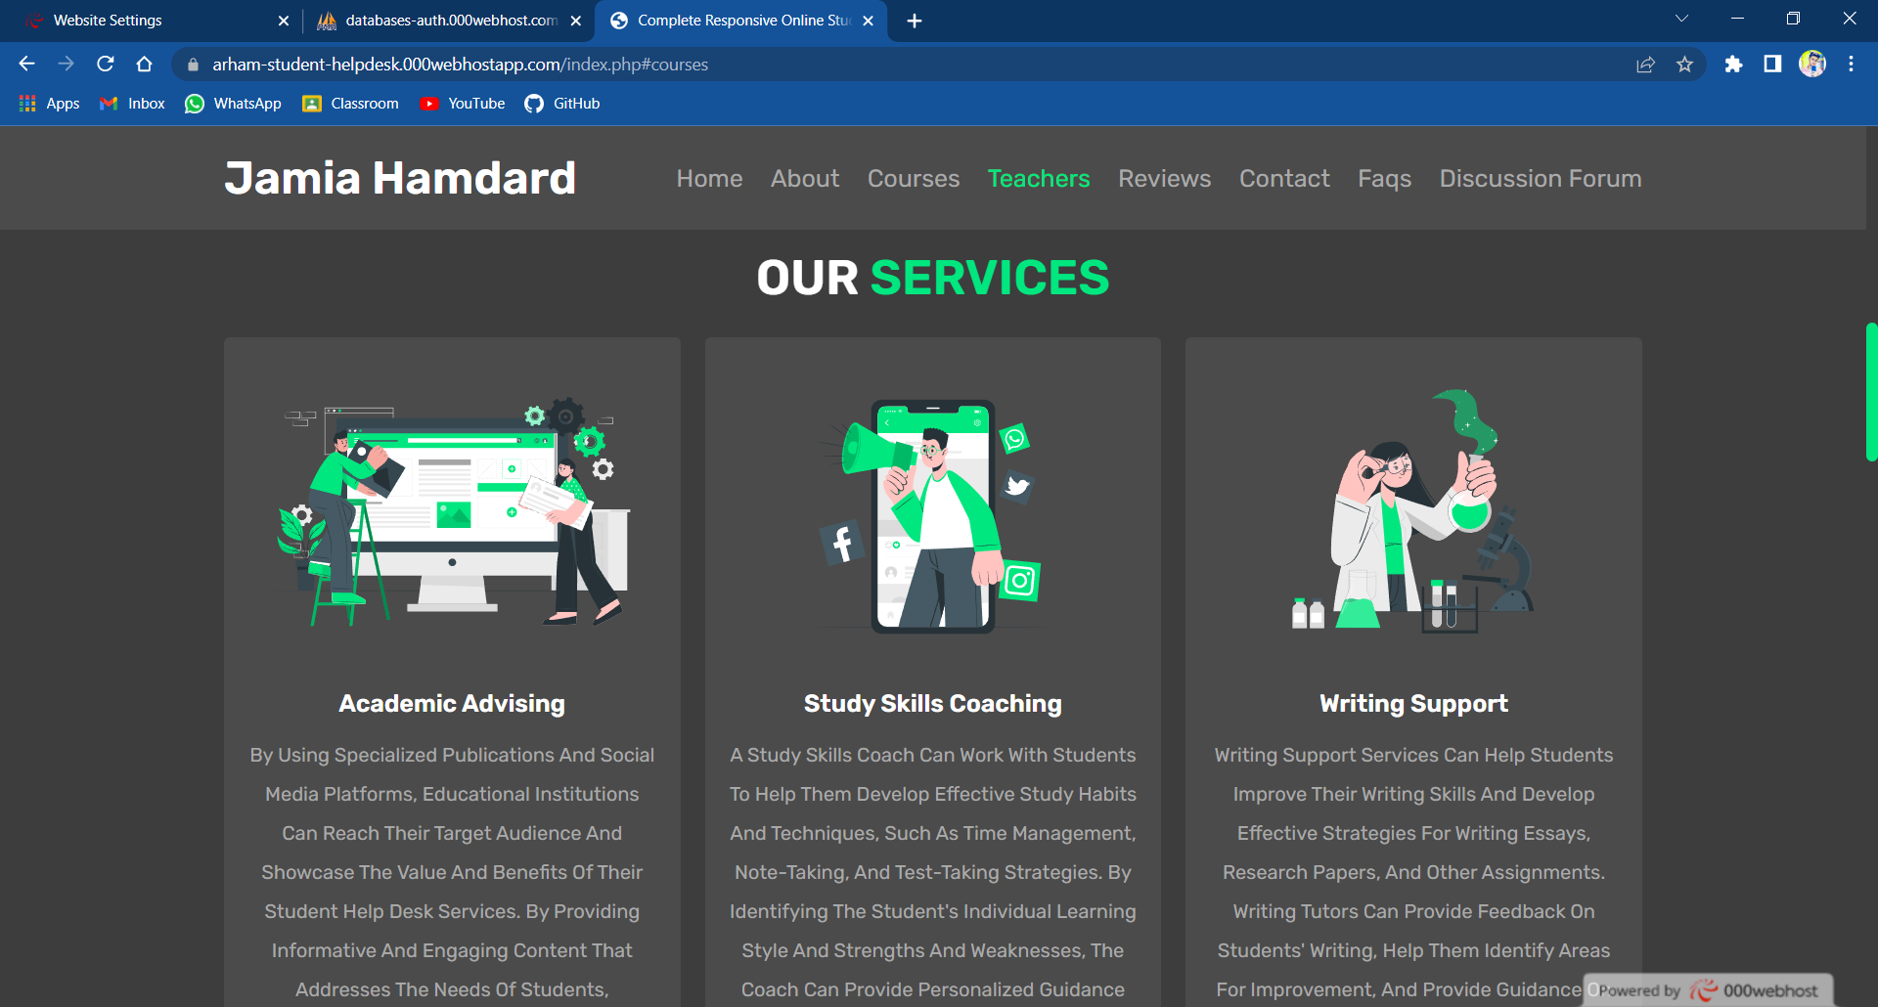

*REVIEWS*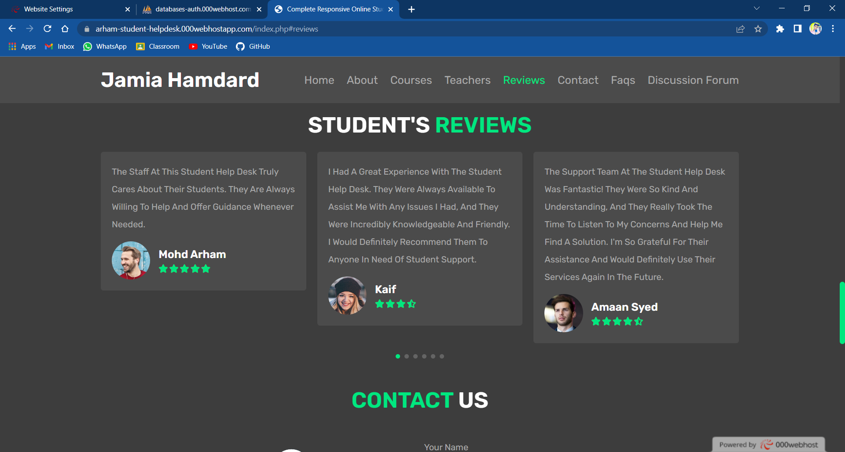

*CONTACT*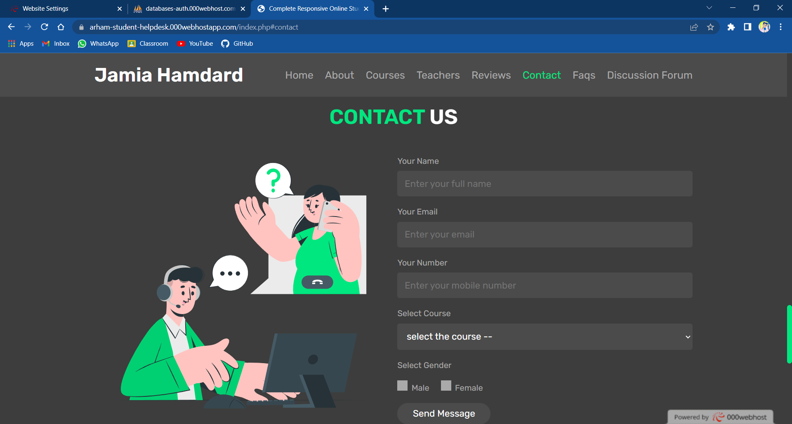

*FAQ’S*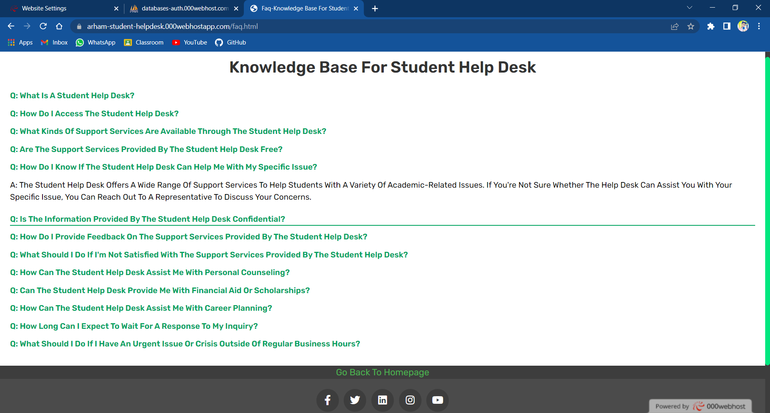

*LOGIN PAGE*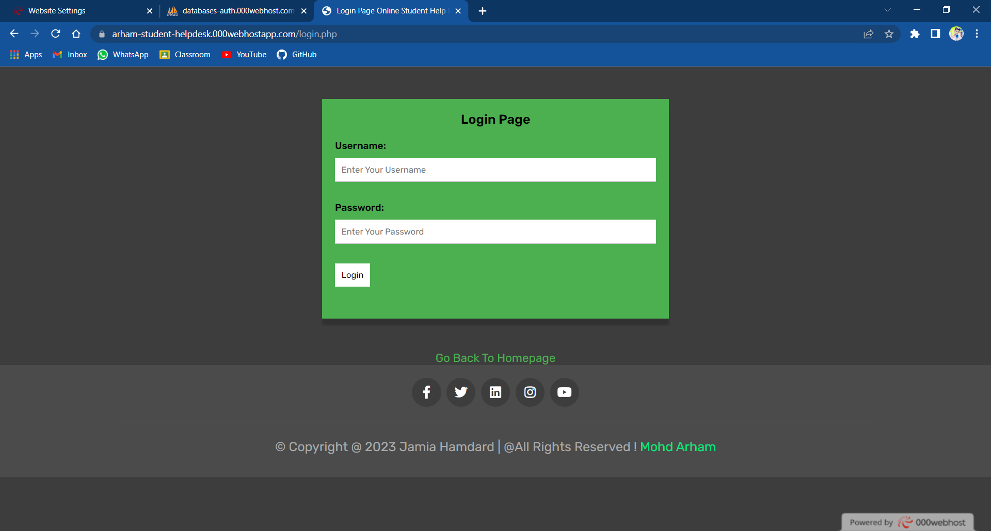

*DISCUSSION FORM*

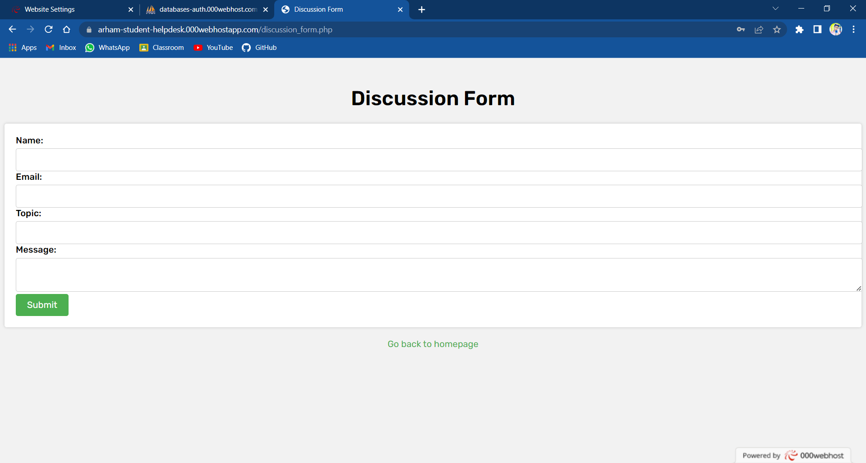

*WEB HOSTING*

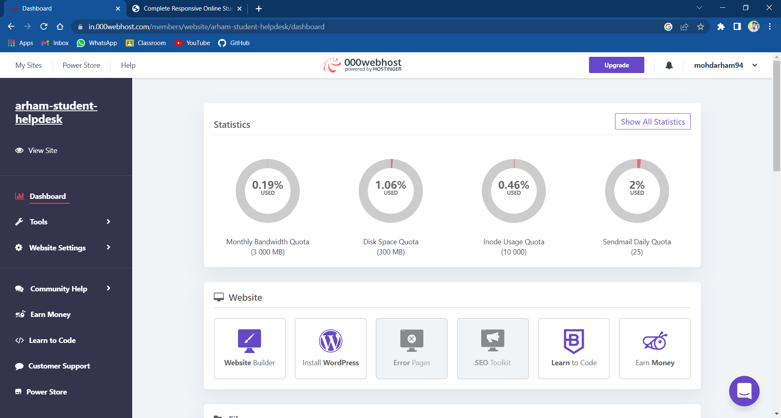

*CODE*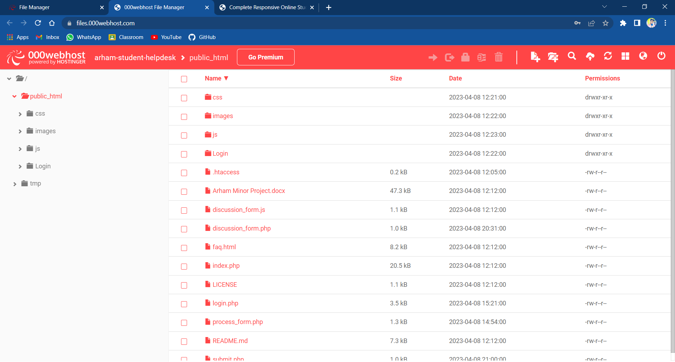

*DATABASE PHPMYADMIN*

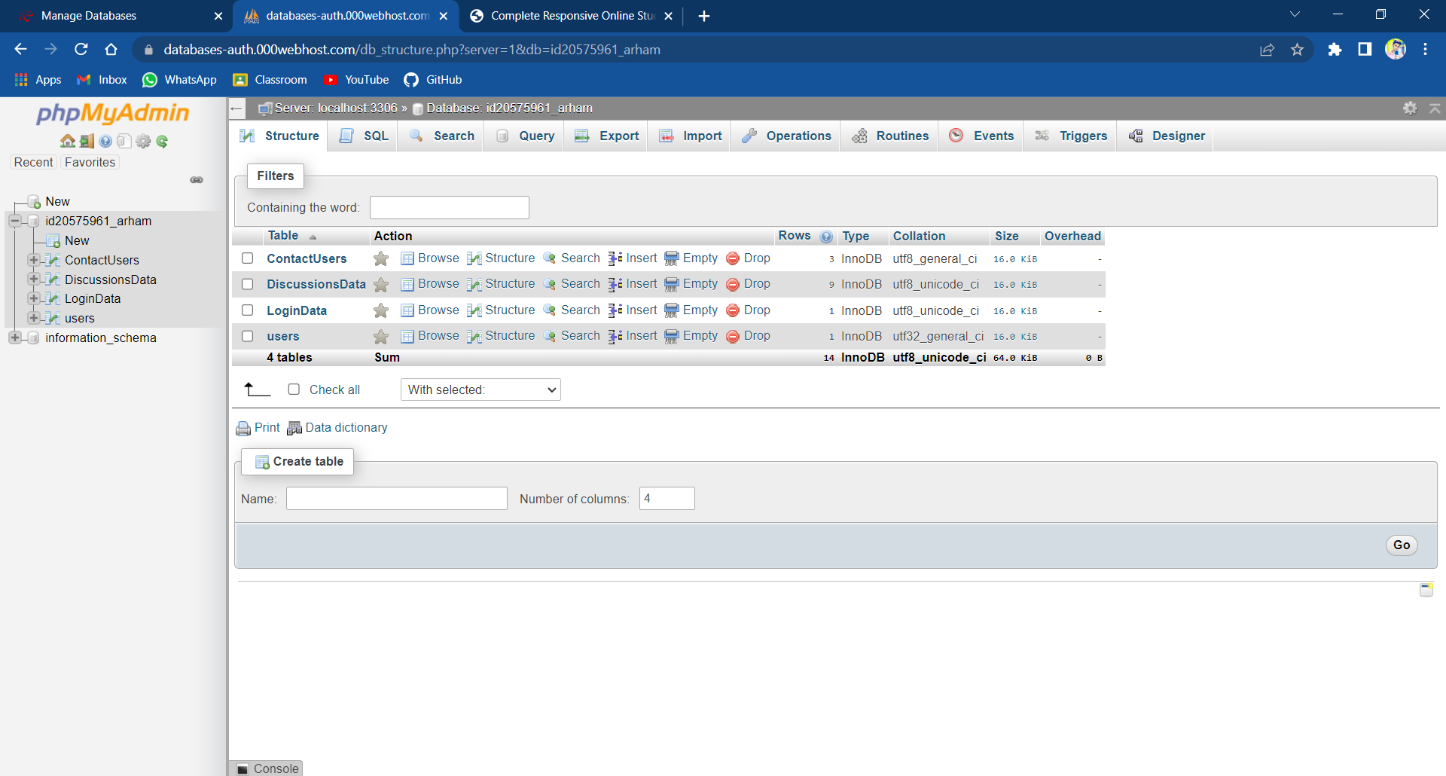

**BENEFITS**

*There are several benefits of a web-based student Helpdesk Management System, including:*

***Accessibility:*** A web-based system can be accessed from anywhere with an internet connection, allowing students to receive support and assistance from anywhere at any time.

***Efficiency:*** A helpdesk management system can streamline and automate the process of handling student inquiries, improving response times and reducing the workload for helpdesk staff.

***Improved student experience:*** By providing timely and efficient support, a helpdesk management system can improve the overall student experience and satisfaction with the educational institution.

***Enhanced communication:*** A helpdesk management system can facilitate communication between students and helpdesk staff, providing an effective and efficient means of resolving issues and answering questions.

***Data management:*** A web-based system can track and manage data related to student inquiries and support requests, providing valuable insights into common issues and areas for improvement.

***Cost-effective:*** A helpdesk management system can reduce the cost of providing support services, by streamlining processes, reducing staff workload and automating tasks.

**FEATURES**

***Course Information:*** Students can access information on course schedules, syllabi, assignments, and more.

***Tutoring Services:*** Students can schedule appointments with tutors and access online resources to help them succeed in their courses.

***Academic Resources:*** Students can find information on academic policies, procedures, and resources to support their academic

success.

***Contact Form***: Students can reach out to the help desk team for support and assistance.

***Feedback System:*** Students can provide feedback on their support experience, which can be used to improve the helpdesk system and ensure that students receive high-quality assistance.

***Social Media Integration***: Students can connect with the helpdesk team through social media channels like Twitter and Facebook, providing another avenue for support and engagement.

***Knowledge Base***: Students can access a database of frequently asked questions and articles related to academic and technical issues.

***FAQ Section:*** Students can access a list of frequently asked questions and answers related to common academic and technical issues.

**CONCLUSION**

* The Student Helpdesk project uses a combination of HTML, CSS, JavaScript, and PHP to create a user-friendly interface that allows students to request help and support from their educational institution. The project features support request handling, a messaging system, and analytics and reports to help staff members provide effective support and improve their performance.
* Student Help Desk reduces the paper work, saves student precious time and solve student queries .
* Student can access this application from anywhere via Internet, since the database is placed on server.
* This idea of student help desk can be implemented by all other departments as well.
* Overall, the Student Helpdesk project uses a combination of HTML, CSS, JavaScript, and PHP to create a user-friendly interface that allows students to request help and support from their educational institution. The project features support request handling, a messaging system, and analytics and reports to help staff members provide effective support and improve their performance.

**Limitations and Future Scope**

***Limitation***

* This Student Helpdesk Webpage has a login page which

allows only enrolled students of Department of Computer

Science to login and thereby preventing unauthorized

access.

***Future Scope***

* Student Help Desk Website can be used by any

department of University.

* The Application can be further enhanced and

several other functionalities can be added.

**BIBLIOGRAPHY**

* **W3Schools. (n.d.).HTML5 Tutorial. Retrieved from https://www.w3schools.com/html/default.asp**
* **Mozilla Developer Network.(n.d.).CSS. Retrieved from https://developer.mozilla.org/en-US/docs/Web/CSS**
* **JavaScript. (n.d.). JavaScript Tutorial. Retrieved from https://www.javascript.com/learn/javascript/first-steps/what-is-javascript**
* **PHP. (n.d.).PHP Tutorial. Retrieved from https://www.php.net/manual/en/tutorial.php**
* **MySQL. (n.d.).MySQL Documentation. Retrieved from https://dev.mysql.com/doc/**
* **Apache HTTP Server. (n.d.).Apache HTTP Server Documentation. Retrieved from https://httpd.apache.org/docs/**
* **XAMPP. (n.d.).XAMPP Documentation. Retrieved from https://www.apachefriends.org/docs/**